Carl Bloch, Master of Historical Painting
Biography
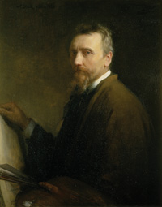
The master painter Carl Heinriech Bloch was born May 23, 1834 in the city of Copenhagen, Denmark. His parents were Jorgen Peter Bloch (whose career was that of a merchant) and Ida Emilie Ulriekke Henriette Weitzman. He had nine other siblings, three sister and six brothers. His family was particularly religious, which is a trait that later on would play a very significant role in his successful career.
In his early youth, he decided he wanted to become a naval cadet, so his parents supported him and enrolled him at the Maribo School. Pretty soon the young Carl found himself enjoying drawing more than his other classes, which became apparent as his grades in other subjects declined, to the point his mother had to hire a tutor. With this new found passion, Carl determined he wanted to become a painter; nonetheless his family opposed him and tried to persuade him to desist in pursuing such career.
In 1849 Carl enrolled at Charlottenborg Palace, where he took drawing classes and received the instruction necessary to eventually become a historical painter. Nevertheless the young artist was mainly interested in portraits and genre painting at this point of his life. One of the most prominent teachers that instructed him was Professor Wilhem Mastrand; and as part of his curriculum, the students had to copy the work of remount artists, as well as drawing live models and figures.
Why Carl Bloch:
The reason I decided to do some research on Carl Bloch, is because I became fascinated with his style. What really captivated my attention was the realism every one of his paintings seems to convey. I have always admired that style of art work, and have always been puzzled with how an artist can achieve such a high level of realism, by using different mediums and techniques. Perhaps Carl Bloch is most famous because of his mastery with oil paintigns and canvas, tough he also, later on in his life, started and became quite good with the ancient technique known as etching, which is technique that I still don’t quite understand, but which nonetheless yields some very interesting and compelling results.
Another aspect that helped me choose to research the master artist Carl Bloch, is the fact that a large portion of his paintings and work was devoted to historical depictions, and more specifically his focus on the historical events of the Bible. As a religious individual who admires the life of the Savior Jesus Christ, the paintings of Carl Bloch seem to bring these stories to life. His realism makes you feel like you are witnessing the very events that the Bible is conveying trough words.
As I read about him, it is fascinating that his passion for art was unstoppable. I admire the fact that despite the constant reproach and lack of support from his family as he chose to become an artist, he was able to leave that behind and prove not only to himself, and his family, but to the world, that he had an special talent and a devoted love for art, and painting in particular. His whole life he strived to perfect and become better as an artist.

TIME LINE

Artist: Carl Heinrich Bloch (1834-1890)
- Born May 23, 1834 in Copenhagen DK Son of merchant Joergen Peter Bloch and Ida Emilie Ulrikke Henriette Weitzmann Bloch.
- Married to Alma Trepka in May 31st 1868
- Died February 22nd 1890

Education:
- 1849 - Royal Danish Academy of Art
- 1851-52 - Attended the W. Marstrand Model School
- 1852 - Won small silver medal for drawing exhibited the following year at the academy
- 1853 - Won large silver medal for drawing exhibited the following year at the academy

Travels:
- 1859-61 - Awarded travel-grant to Holland, Belgium, France and Italy.
- 1863-66 - Italy (Rome, Sorrento, Naples, Palestrina)
- 1864 - Athens
- 1865-66 - Firenze, Italy
- 1866-90 - Numerous short trips to Holland, France, and Italy

Awards & Honors:
- “Councilor of State”
- “The Cross of an Order of Chivalry”
- “The Medal of Dannebrogmen”
- 1865 - Commissioned by brewer J. C. Jacobsen for 23 images to hang in the newly restored Fredericksborg Castle.
- 1888 - Self Portrait hung at the Uffizi in Florence, Italy.

Positions & Appointments:
- 1865 - Became a Member of the Royal Academy of Fine Arts
- 1871 - Became a Professor at the Royal Academy of Fine Arts
- 1873-76 - Council Member at the Royal Academy of Fine Arts
- 1876, 79, 82, 83 - Reappointments as council member
- 1887 - Member of Gallery Commissions
- 1888-90 - Vice Director at the Royal Academy of Fine Arts

Exhibits:
- 1853-1890 - Charlottenborg Palace, DK
- 1872, 83, 88, 90 - Nordic Exhibition in Copenhagen
- 1878 - Paris
- 1881 - Nordic Exhibition in Gothenburg
- 1882 - International Art Exhibit in Vienna
- 1891 - International Art Exhibit in Berlin
- 1910, 16, 21, 26, 32, 41, 42, 54, 60, 69, 75, 77, 78, 81, 83, 86 - Association of National Art Exhibition in Copenhagen / In Honor of Carl Bloch
- 1907 - London (Guildhall)
- 1977 - Rome
- Currently, many of his pieces are on display in museums through out the world.

(Source: www.carlbloch.com)

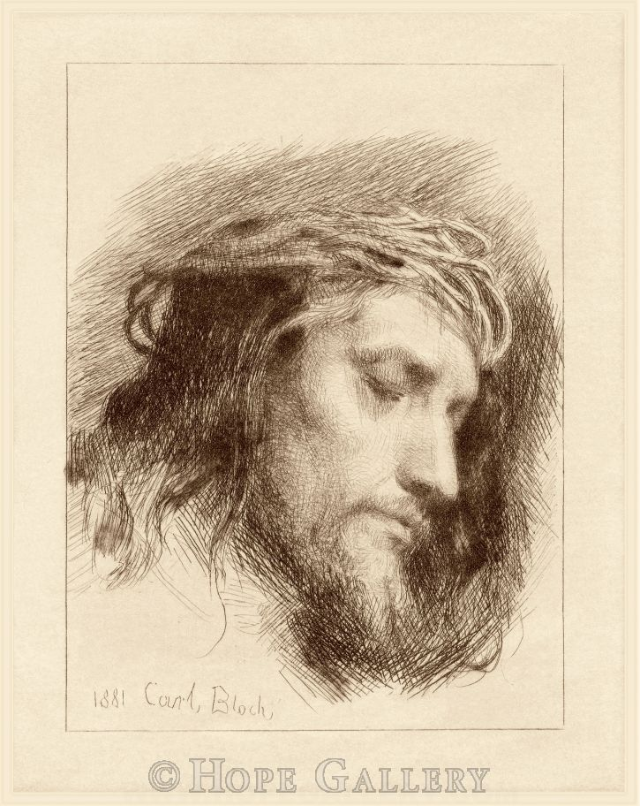
The reason I like this etching titled: Christ’s Head with a Crown of Thorns” from 1881 it’s because I find it very expressive. What its interesting is that the face of Jesus Christ seems to transmit a sense of peace and calm despite the fact the fact that a crown of thorns is digging in his head. Also what makes this piece so interesting is the fact that he used the technique known as etching to produce this piece. Form the research I made on the subject, it is a very complicated process. Yet Bloch strived to learn it as best as possible, and the results are truly remarkable. When I first saw this etching I thought it was an ink sketch he had produce. The level of detail and the cross hatching are very precise. And as we have studied in this class, he takes full advantage of dark and light values to make it stand out by using just lines overlapping.
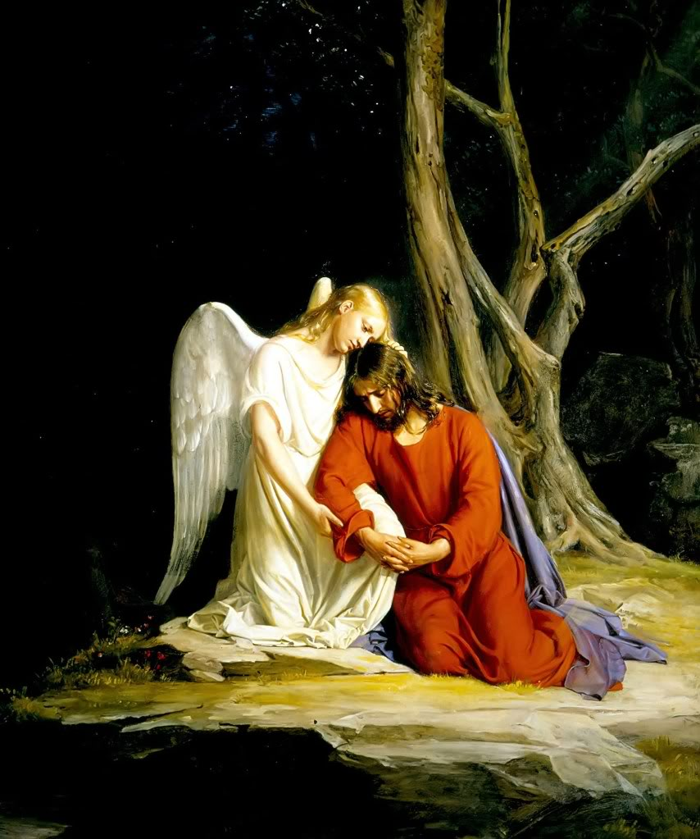
“Christ in Gethsemane” painted in 1975, it’s a unique piece in my opinion, because its depicting a very crucial moment in the ministry of Jesus Christ. What makes this painting stand out is the fact that he chose to depict the angel in this scene, which is a part of the story a lot of people don’t focus on, or bring up. In this painting he very well balances the picture by putting Christ and the angel in the very center. And surrounding them with a pitch black background to intensify the event, where the white robes of the angel and the red robes of the savior contrast very strongly. Going back to the robe, I like the fact that he chose to depicted as red, since part of the biblical account is the fact that Christ bled from every pore. Bloch effectively conveys the agony and suffering of the event, helping the viewer feel part of the scene. The account can be found in the New Testament. Luke 22:39-44.

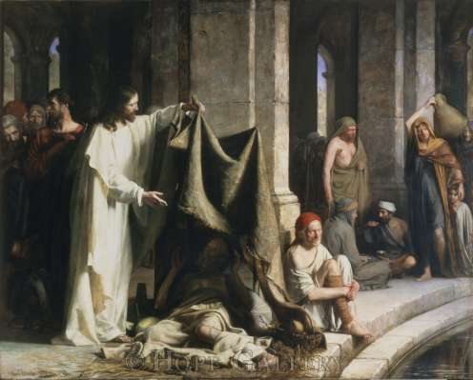

“Christ Healing the Sick at Bethesda” painted in 1883. This painting incorporates the principle of perspective really well, which helps give the painting realism. He also pays a lot of attention to the surroundings of the main subject he is trying to portray, which I find adds tremendously to the message he tries to convey. The fact that there are so many people in this scene, makes you wonder what the story of each one of them is; what is going through their mind, which I think is a great quality and trademark every painting from Bloch has. There is so much more going on in every painting and in particular this one helps show that. Bloch is a master at manipulating the strokes and the paint to create detailed surfaces and again his use of value adds a more dramatic effect to the scene by focusing the views attention to the brightness of Christ in relation to the darkness that surrounds him, which I believe can be taken as a symbolism as well.
Sources

“Bloch, Carl” carlbloch.com 2009. Web. 18 Jul. 2011

Pheysey, Dawn, and Nietzel, Richard Holzapel “The master’s hand, the Art of Carl Heinrich Bloch”
Deseret Bookk Company. 2010. “Printed.

