Sports: Why are they part of the American Culture?
by David Herrera Jun. 24, 2011

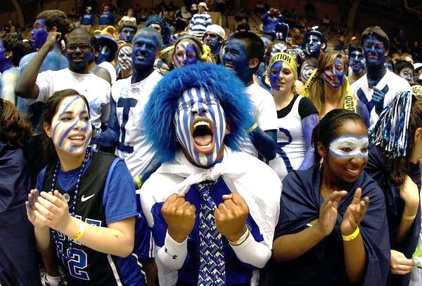
Cameron crazies

Sports are an essential part of the American culture and continue to incorporate themselves in one or more aspects of the individual lives’ of the American people. Therefore some questions arise that can direct towards a satisfactory answer of why this happens. Such questions include: what are some of the reasons behind this phenomenon? Can one scape from the influence of sports? What are some of the aspects of life that sports are a part of?

The Moment
In an attempt to answer some of these questions first picture the following scene for a moment: There are 46 seconds left on the clock of the 4th quarter, your team is losing 83 to 86 and you are to the point of complete exhaustion. None the less, you manage to leave all of these behind, take the ball from your opponent and race down the court and score two points, thus closing the score gap by one point. If that wasn’t enough, you now have 37 seconds left and your opponent, has control over the ball and is about to score…but suddenly you sneak behind him unnoticed, smack the ball out of his possession and leave him on the ground! Then you take off down the court pass the three point line, do a crossover dribble that fakes one of the defenders and leaves you wide open to then magically float in the air with less than 8 seconds left, to release the ball and hope that it will switch through the hoop. You follow through with your shot …the crowd goes quiet for moment… and the ball goes through the hoop and gives your team the victory of 87 to 86 in game 6 of the finals! ; At first glance the previous narrative might sound like something out of a movie; but in fact this event took place in the 1998 NBA finals (Chicago Bulls vs. Utah Jazz), with Michael Jordan as the protagonist of such feat.
Physiological aspects of Sports
The remarkable victory of the Chicago Bulls against the Utah Jazz serves as an appropriate example to illustrate why we love sports. By studying closely the scene, the event contains most of the psychological explanations of why a person is drawn towards sports as outlined by the writer Sam Vaknin:
- Vindication: the triumph over oneself or other competitors.
- Predictability: the rules set create a safe/controllable environment.
- Simulation: sports have aspects of real (i.e. drama, conflict, winning, loosing,).
- Reversibility: the principle that there will be another opportunity (i.e. next year’s finals).
- Belonging: teamwork, bonding, fan clubs.
- Narcissistic Gratification: creating a sense of expertise amongst the sports fans (i.e. Fantasy sports)
Vaknin explains in his article that “sports cater to multiple psychological and physiological deep-set needs. In this they are unique: no other activity responds as do sports to so many dimensions of one's person, both emotional, and physical. But, on a deeper level, sports provide more than instant gratification of primal (or base, depending on one's point of view) instincts, such as the urge to compete and to dominate.”

Something for Everyone
Because sports appeal far beyond the immediate needs of a person, they gradually find a spot they can fill in the ordinary lives of multiple audiences; just by walking around a super market, one can start seeing sporting merchandise that targets multiple and diverse levels of sports identification and involvement. For instance, take into consideration the following items which can be divided into active and passive participation in sports: a football, a jersey, an NBA video game, tickets to a live sporting event, Sports illustrated magazine. Most people at some point have played a sport, whether for fun, for an institution or professionally, which would make up the active portion of the list. The remainder of the list is consists of items that would be considered passive participation since the person is not actually engaging in the sport.
Looking at each item, the aforementioned psychological aspects can be identified. The jersey and the tickets reflect the aspect of belonging, since they create a unique identity to which entire cities or communities can became part of, thus creating the effect of unity and fulfilling the social aspect among spectators, and a sense of oneness within a team. The video game and the Sports illustrated magazine fall under the narcissistic aspect, which is best explain by the following excerpt:
It takes years to become a medical doctor and decades to win a prize or award in academe. It requires intelligence, perseverance, and an inordinate amount of effort. One's status as an author or scientist reflects a potent cocktail of natural endowments and hard labor.
It is far less onerous for a sports fan to acquire and claim expertise and thus inspire awe in his listeners and gain the respect of his peers. The fan may be an utter failure in other spheres of life, but he or she can still stake a claim to adulation and admiration by virtue of their fount of sports trivia and narrative skills. (Vaknin)
The football, which would represent gear used in the actual playing of sports, can be included in the category of vindication because to become proficient in a sport, it requires dedication, hard work, and a desire to reach higher levels beyond one’s one ability.
24/7 access
Another reason why sports have become increasingly popular can be attributed it to the massive media coverage. Simply by channel surfing one can stumble across stations like ESPN or Fox Sports, which are fully devoted to sports coverage; or on a smaller scale, the sports section in the local news and the news paper. With the current technology, broadcasting helps to propagate sports to a variety of demographic and geographic areas.
ESPN, which reaches 70% of American homes with televisions, broadcasts more than 8,000 hours of sport each year. Regional sport cable networks and direct satellite sport broadcasts are growing rapidly, and these generate countless thousands of hours of sport each year. (Sage)

Since not everyone can go to a live event, television, the radio and the internet make it ever so simple to feel like you are right at the stadium. So whether the spectator is looking to support his or her favorite team, to be entertained, or to witness man and women push beyond their physical abilities; the mass media provides almost limitless ways and means to do so.
A role model is born
Professional sports enable men and women to be shaped into the best they can be in their discipline. Thus a breeding ground for excellence is created, and naturally, human beings look up to exceptional individuals and aim to emulate or even incorporate some of their positive attributes. In an article by the USA today these idea is evident when an Katarina Witt, the two-time Olympic gold medalist in figure skating is asked about her thoughts on role models:
"I absolutely think that athletes should be role models," Witt said at the Vancouver Winter Olympics. "Being an athlete out there, yes, of course, you are a human being, too, and you will have a few mistakes, but I always wanted to be a role model for kids — to show them what it means to train hard, to become the best in one thing you do." (Weir)

It pays to be involved in sports
There is no doubt that the sports industry brings exorbitant amounts of revenue. This coupled with the media, create an incentive to target as many people as possible and create ways to bring consumers more ways to interact with sports. When it comes to the financial aspect, some of the main groups that can be identified who benefit and make a career of sports include professional athletes sign multi million contracts every year (just from 2002, the average MLB salary was $2.3 million, refer to table 1) the advertising companies that promote their products through top athletes; broadcasting stations who buy the rights to transmit sporting events.
All NFL television money is split evenly among the teams, for an average $73.3 million per team per year. The rate is thus much higher than what MLB teams derive from that league’s network TV deal, which is not quite $11 million for each club. About 65% of all revenues of NFL teams comes from the sale of television rights (Sage)

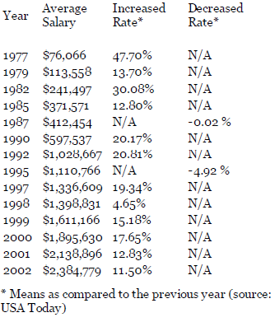
Also clothing and sporting goods companies can be included since they rely on the ever increasing demand for better and more sophisticated equipment for both amateur and professional athletes alike.
Table 1. Average MLB salaries over time (Soonhwan)

Conclusion
Sports are part of the American culture because they contribute to the emotional, social and physical needs of the American culture. No matter what age a person might be, or where in his or her life they might be, sports can be easily accessible. The multifaceted nature of sports reminds us that each individual must take a step into this world and figure out what importance to give to this subject. The deeper the introspection achieved, the more reasons of why America has fallen in love with sports will continue to appear and amaze.

Sources
Soonhwan, Lee. Economic Values of Professional Sport Franchises in the United States. thesportjournal.org. Web. June 25, 2011

Vaknin, Sam. Why do we love sports? theglobalpolitician.com. Web. 4 Dec. 2008
Weinberg, Rick. 24: Jordan’s Jumper secures 6th NBA title. espn.com. ESPN Internet Ventures, 2009. Web. 21 Jun. 2011
Weir, Tom. Fans still love their sports, but think twice about hero worship. USA Today. Web. 25 Feb. 2010.
“Top 15 Greatest Sports Moments of All Time” listverse.com. 15 Nov. 2008. Web. 20 Jun 2011
Pictures & Table
Brodess, Doug. March Madness 2011: 16 Mind-Blowing Stats From the Sweet 16 Teams. bleacherreport.com. Web. 24 Mar. 2011

Soonhwan, Lee. Economic Values of Professional Sport Franchises in the United States. thesportjournal.org. Web. June 25, 2011

