
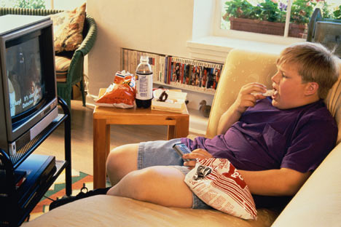

www.helpcurechildobesity.com
www.ussa.com
www.sportscareers.com

“Football is like life -- it requires perseverance, self-denial, hard work, sacrifice, dedication and respect for authority.”
Vince Lombardi
American football coach
Benefits sports provide our Children

Putting your children in sports at a young age can instill values that will stay with them into adulthood

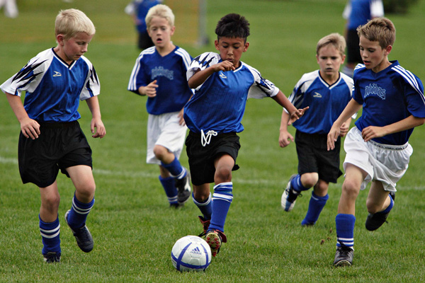

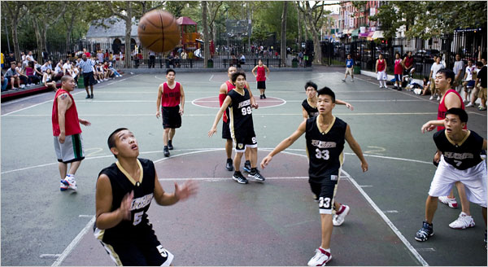

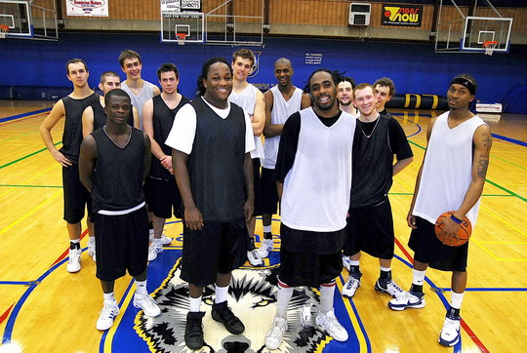

The evidence supporting sports participation for young people is overwhelming...It has the power to combat everything from racism to low self-image, to the high-school drop-out rate." (Sue Castle, Executive Producer of PBS Sports: Get in the Game)



- Teamwork
- Leadership
- Hard work
- Ethics
- Discipline
- Competitiveness
- Self-confidence
- Respect
- Commitment
- Perseverance

- By putting your child in sports you not only help them learn many great values you can also help them to be healthy
- There are many career opportunities that will be available for you children long after they are done playing if you get them involved!


Being involved in sports can provide your children with excellent career opportunities
“The spirit, the will, and the will to excel are things that endure. These qualities are so much more important than the events that occur.” Vince Lombardi

In the last 30 years child obesity has tripled to 15% (helpcurechildobesity.com)
Simply by involving your children in sports it gives them the ability to stay active and avoid being a part of this statistic.

As a parent you have the ability to make a difference in your children’s lives from the beginning by encouraging them to be active!

“Leave all the afternoon for exercise and recreation, which are as necessary as reading. I will rather say more necessary because health is worth more than learning” Thomas Jefferson

Most people think of pro sports as the only way to make it in the world of sports, but there are other options such as:

- Coaching
- Sports Agent
- University and High School Administration

- Trainer
- Executive in a pro organization
- Physical Therapist
Just to name a few!!

Being Active can keep your Child Healthy

Photo courtesy of lehrn.org

Your children are tomorrow’s leaders

